

Workshop 2 = How To Sample (facilitated by Stacey Harbot and Melisa Canales)

Briefing:

How to manage your environmental screening: how to sample, who should sample, policies and paperwork and most importantly a practical session on taking screening swabs for bacteria and viruses.

Setting

Screening of the environment for microorganisms can be more complicated than it initially appears. Factors such as training, sampling technique, sampling method, detection method and interpretation can all influence the clinical application.

Questions:

- What organisms are you looking for?
  - Bacteria/viruses/fungi
- When are you sampling, outbreak vs routine?
- How did you decide how many samples to take?
- How did you select your sampling locations
- How did you decide on your process, who takes the samples, who processes them, who interprets the data, who trains those involved?
- How do you follow up on the organisms, typing etc?

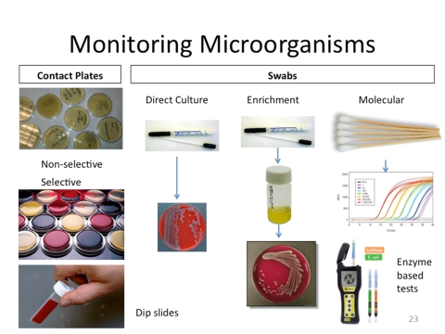

Questions:

- What type of swabs would you use in your organisation for viral sampling?
- What king of swabs (with or without transport medium) would you use for bacterial sampling?
- Under what circumstances do you use the other testing techniques?
- Do you use enrichment methods or direct
- Do you use bacterial culture or molecular techniques?

Design Matters
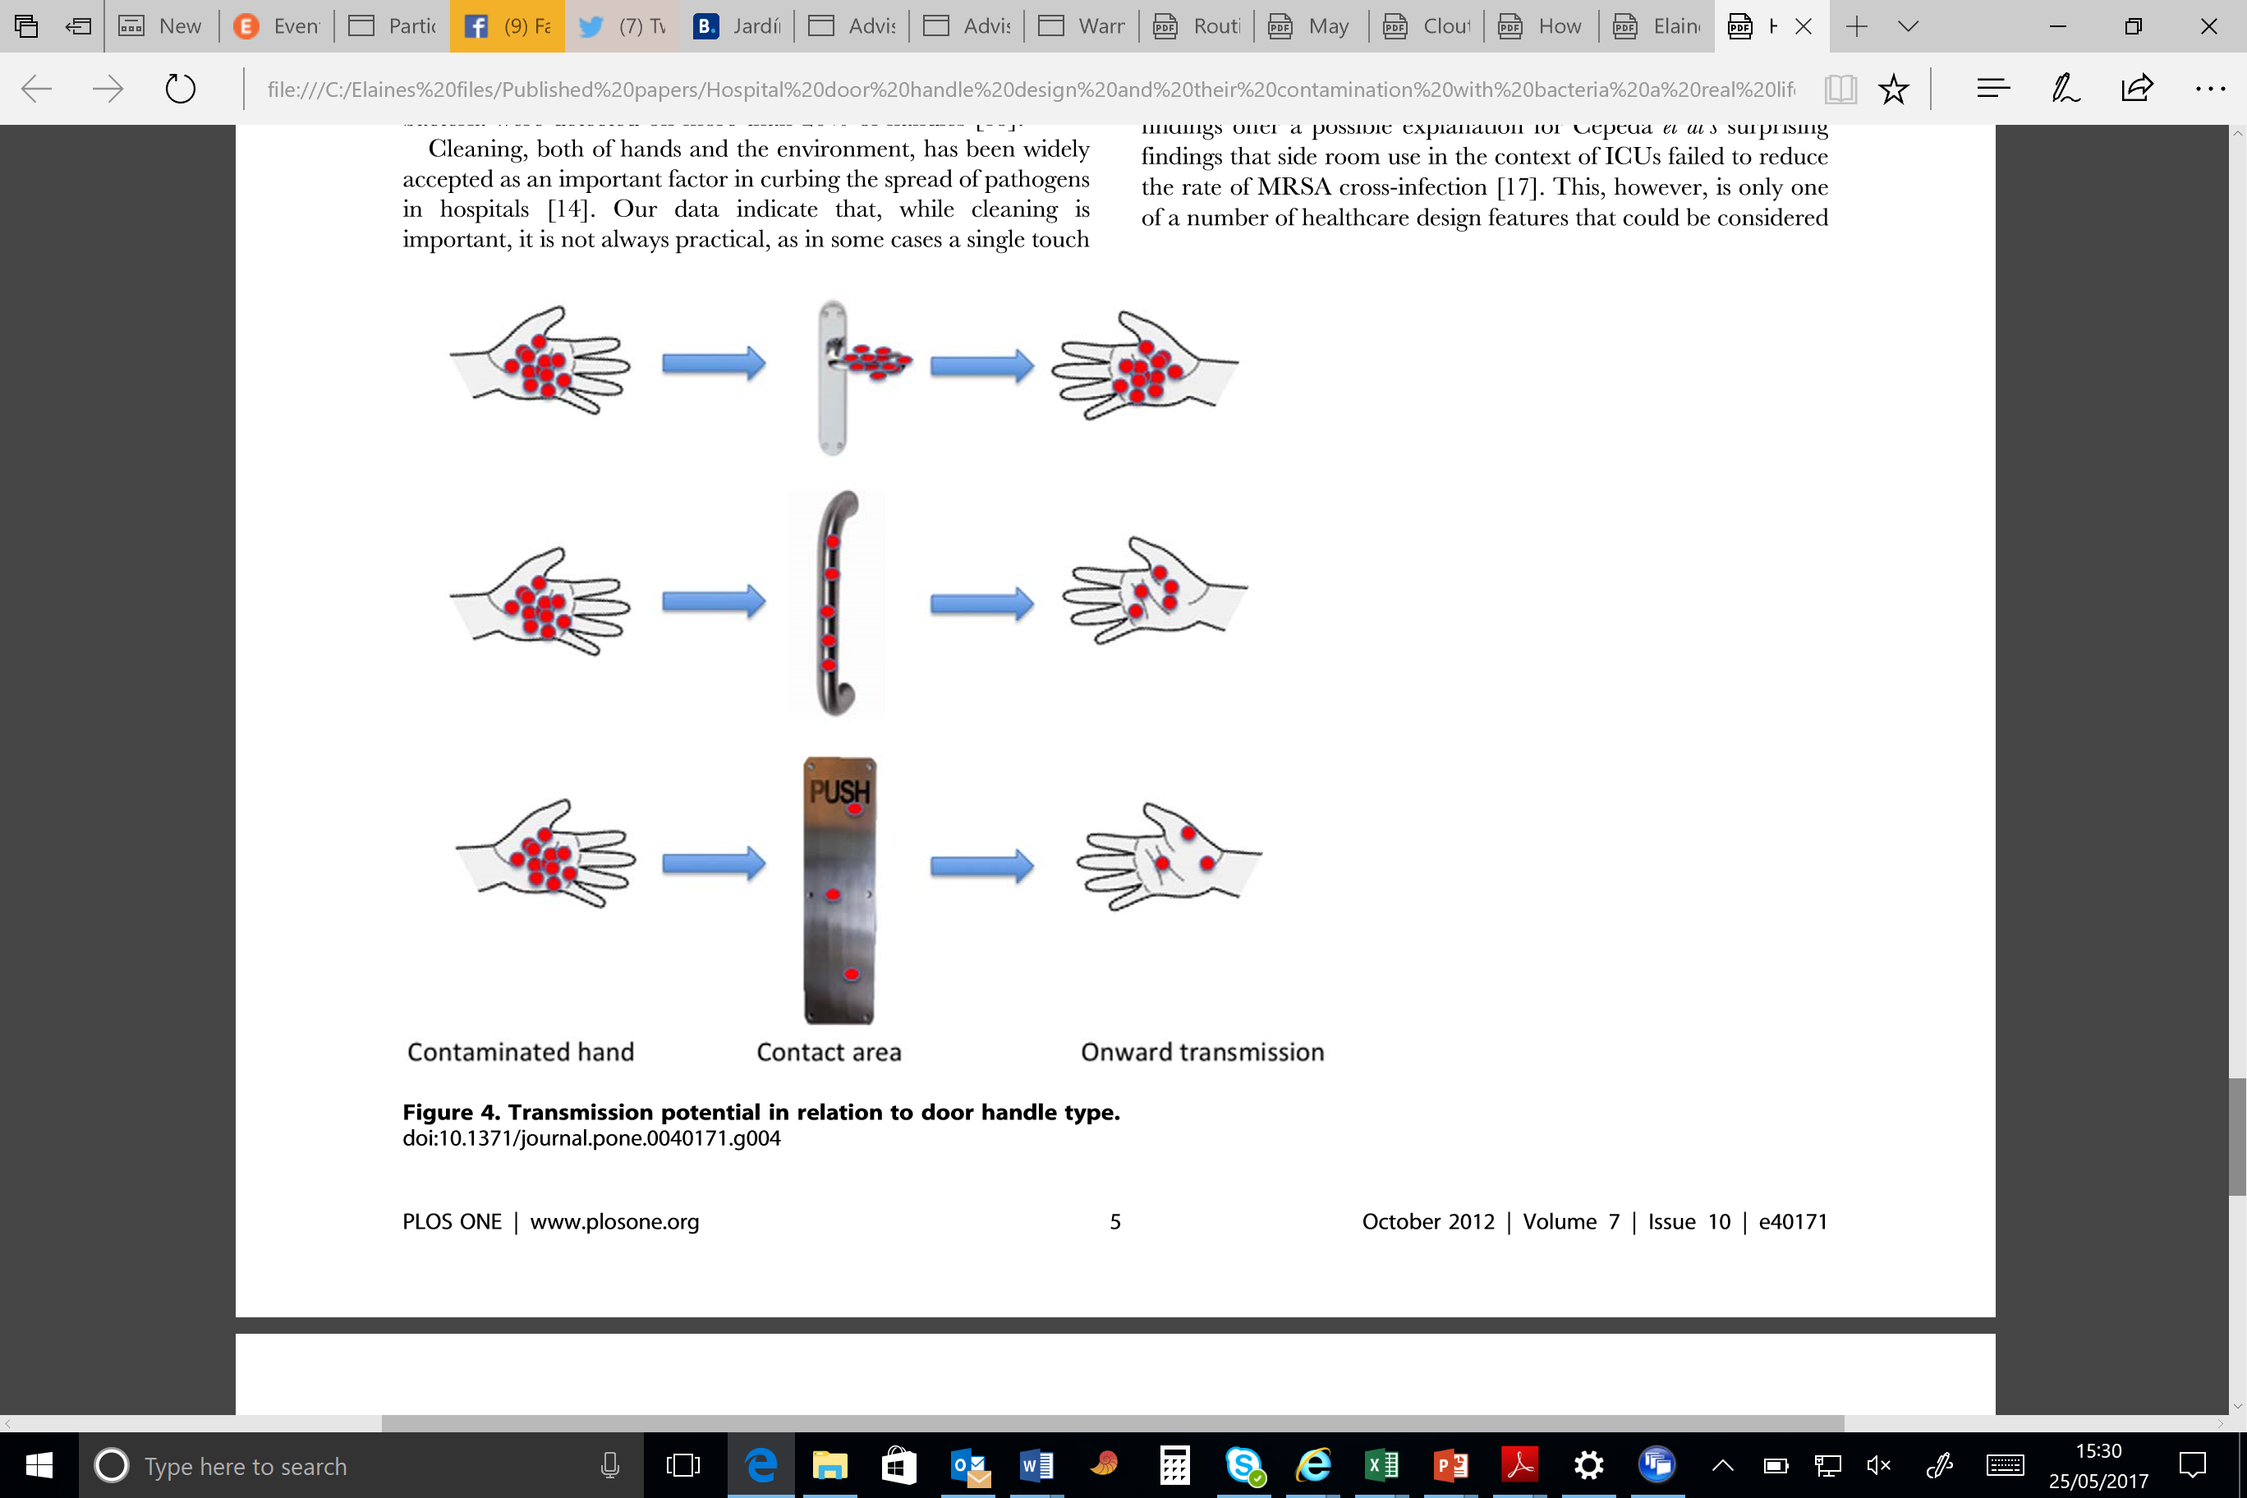

Biofilm Plays a Role
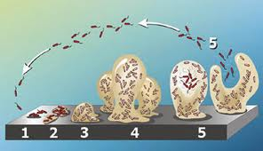

All Sampling is Not Equal
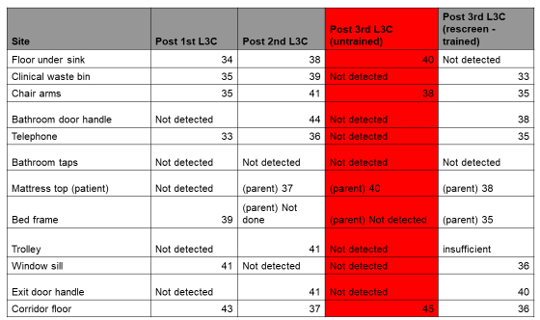
Adenovirus on surfaces post clean (visibly clean), numbers = cycle threshold of real time PCR

