

Case Study 3 = Was it Always the Biscuit Tin? (facilitated by Derren Ready)

Briefing:

Environmentally mediated viral outbreak – Gastric virus outbreak with a possible environmental source. What investigations and interventions are appropriate for both the environment and patients.

Setting

Patients on the haematology/oncology wards have weekly stool screening to identify any cases of gastric viruses by polymerase chain reaction, with additional samples sent on commencement of any gastric symptoms. The ward area is routinely cleaned with chlorine, and all patients are in single mechanically ventilated cubicles with dedicated on-suite.

One patient becomes symptomatic and is detected as Norovirus positive after less than 48 hours as an inpatient. A second inpatient on the same unit becomes positive 21 days later, rooms are geographically separate and both are in isolation for their bone marrow transplant.

Two days later two members of staff phone in sick with diarrhoea and vomiting.

Questions:

- What agent do you use to routinely clean your wards?
- What items are cleaned by:
  - Cleaners
  - Patients
  - Nursing staff
  - Healthcare assistants/other staff
- Do you monitor for asymptomatic carriage of gastric viruses?
  - Which groups?
  - How do you screen?

Outbreak continues for 3 months, after the first 3 weeks no new patient cases are detected. Staff cases continue to be detected on a weekly basis with some cases of staff being sent home after vomiting in communal toilets.

Questions:

- What actions would you take?
  - Would you make any changes to your cleaning?
- Do you have a policy for vomiting in communal toilets? What is it?
- What policy do you have in terms of staff working between units during an outbreak?
- What policy do you have in terms of time off sick for with diarrhoea and vomiting?
- If you were to undertake environmental screening, how would you screen:
  - Who would do the screening?
  - What methods would you use?
  - How many samples would you take?
  - Which areas of the ward space would you screen (shared ward, bed spaces (all), bed spaces (affected)
  - Who would process the samples?
  - What interpretation criteria would you use?
- Do you do any non-outbreak screening to know your baseline rates?
- What policies do you have about eating and drinking in clinical areas? How do you audit/enforce them

Environmental screening results show:
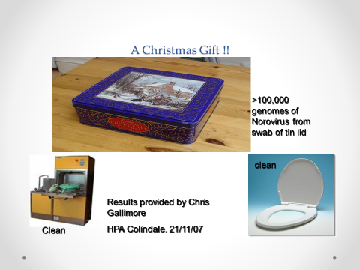
Staff cases continued for a further 2 months and the outbreak resolved on disposal of the biscuit tin.

Setting (1)

Do you undertake any routine screening for environmental viruses in the absence of outbreaks or cross transmission events?

Routine viral screening of shared ward areas for Norovirus (NV) and Adenovirus (AV) using molecular techniques on the haematology/oncology ward (HSCTU + IIU) (not during the same outbreak period):

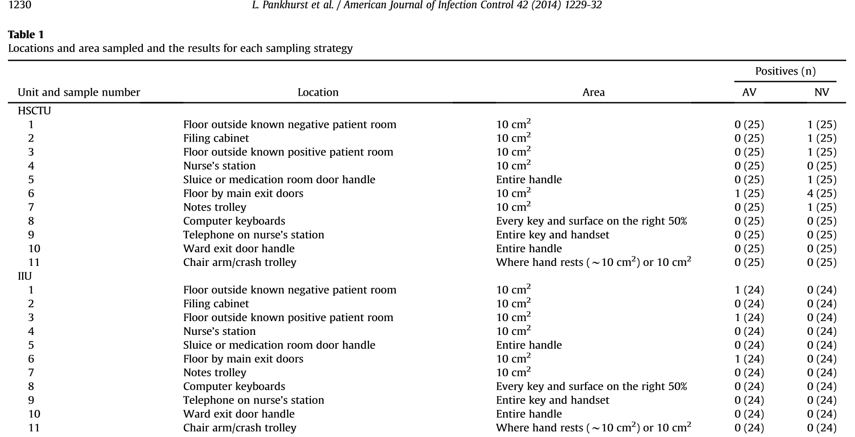

One patient becomes symptomatic and is detected as Norovirus positive after less than 48 hours as an inpatient. A second inpatient on the same unit becomes positive 21 days later, rooms are geographically separate and both are in isolation for their bone marrow transplant.

Two days later two members of staff phone in sick with diarrhoea and vomiting.

Questions:

- What interventions would you undertake? i.e. would you:
  - Hold an outbreak meeting
  - Change cleaning
  - Change visitation
  - Close the ward to admissions
  - Undertake patient screening
  - Undertake staff screening
  - Undertake environmental screening
  - Send viruses for typing
  - Other

Setting (2)

Outbreak meeting undertaken leading to:
  - Increased ward and cubicle cleaning
  - Reduced visitors
  - Reduced movement of equipment
  - Patient screening
  - Remind staff to remain off for 48 hours post any symptoms
  - Enforcement of restrictions linked to eating and drinking in bed spaces and in cubicles

Ward remained open to admission and no environmental screening undertaken. Over the next two weeks 12 members of staff go off sick, no further identified patient cases. Member of staff vomits in communal toilets.

Questions:

- What further actions would you take?
- Do you have a policy for vomiting in communal toilets? What is it?
- What policy do you have in terms of staff working between units during an outbreak?
- What policy do you have in terms of time off sick for with diarrhoea and vomiting?
- If you were to undertake environmental screening, how would you screen:
  - Who would do the screening?
  - What methods would you use?
  - How many samples would you take?
  - Which areas of the ward space would you screen (shared ward, bed spaces (all), bed spaces (affected)
  - Who would process the samples?
  - What interpretation criteria would you use?
- What policies do you have about eating and drinking in clinical areas? How do you audit/enforce them

Setting (3)

Enforcement of the policy of immediate closure of communal toilets if any vomiting reported until they can be cleaned including walls with chlorine (wait for 30 minutes post closing to allow viruses to settle).

Environmental screening results:

40 samples taken from the shared ward areas and staff areas for viral PCR (y axis = cycle threshold, closer to 40 = less virus)

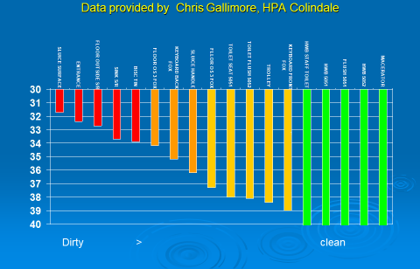

Biscuit tin in the staff room had over 100,000 copies/ml of norovirus. Other highly positive sites included:
- Sluice
- Floor at the ward entrance
- Sink in the sluice room

Questions:

- Do any of the ‘clean’ sites surprise you? Do you believe that this was due to cleaning? Design? Other?
- Whose responsibility is it to monitor the food in the staff room?
- Would any of your screening algorithms include the biscuit tin? (we did it because we had a spare swab)
- Do you think other gastric viruses would behave the same way?

Setting (4)

Outbreak lasted for 3 months, after the first 3 weeks no new patient cases were detected. Staff cases continued for a further 2 months and the outbreak resolved on disposal of the biscuit tin.

