
Case Study 1 = That Sinking Feeling (facilitated by Helen Dunn)

Briefing:

Environmentally mediated bacterial outbreak – Klebsiella species outbreak with a possible environmental source. What investigations and interventions are appropriate for both the environment and patients?

Setting

Patients on the haematology/oncology ward have universal admission screening for antibiotic resistant Enterobacteriaceae, plus additional weekly stool screening to identify any cases that arose through either cross transmission or antibiotic selection. All patients are in single mechanically ventilated cubicles with dedicated on-suite.

Questions:

- What admission screening do you undertake on your units for antibiotic resistant Enterobacteriaceae? Does it vary by ward?
- Do you undertake further non-clinical screening?
- What samples do you test and how?
- What is your definition of ‘antibiotic resistant Enterobacteriaceae’

8 patients over 8 months with Klebsiella pneumoniae sub species pneumoniae detected in stools (more patient were detected subsequently)

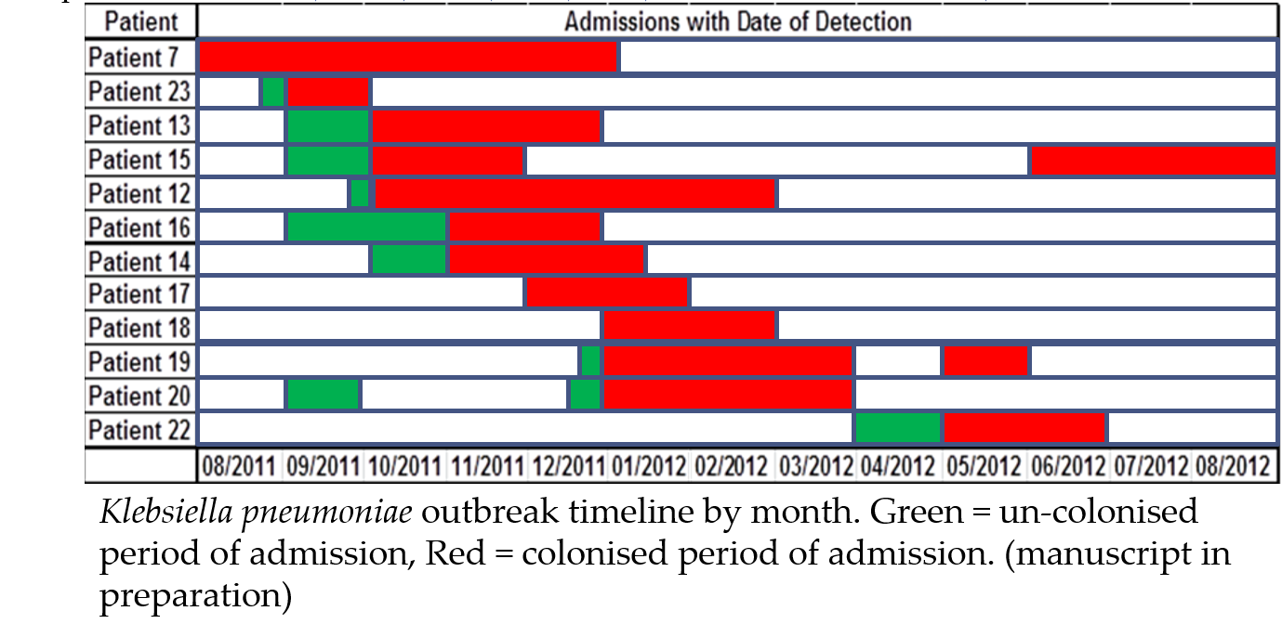

Questions:

- What actions would you take for:
  - Patients
  - To identify the source?
  - To control the outbreak?
- Are there any particular places you would consider screening due to the identity of the organism (Klebsiella pneumoniae sub species pneumonia)
- What further organism follow up would you consider?
- What aspects of Klebsiella pneumoniae mean that is might be environmentally transmitted?
- How does this knowledge help you decide where to screen?

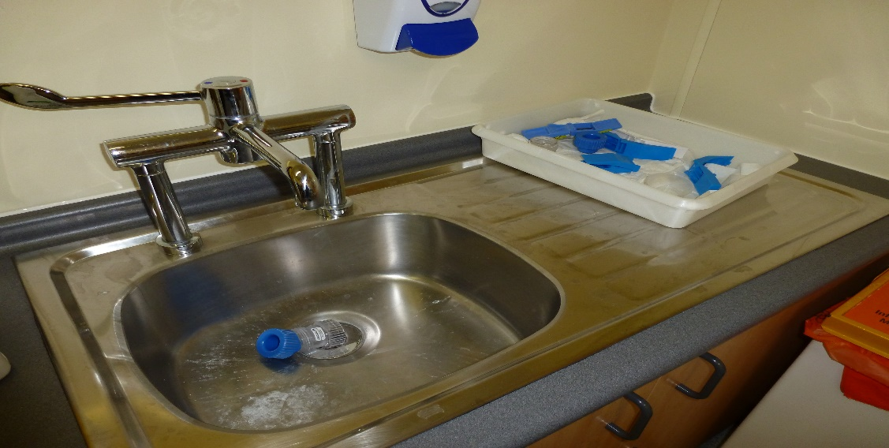

Environmental screening showed 1 positive swab for the same strain detected, taken from the IV room sink

Questions:

- Would you undertake any further environmental screening at this point?
- What actions might you take linked to the positive sink?
- Do you have any comments on the design of the sink?

Infection control interventions still in place, including 2 hourly cleaning and changes in sink use.
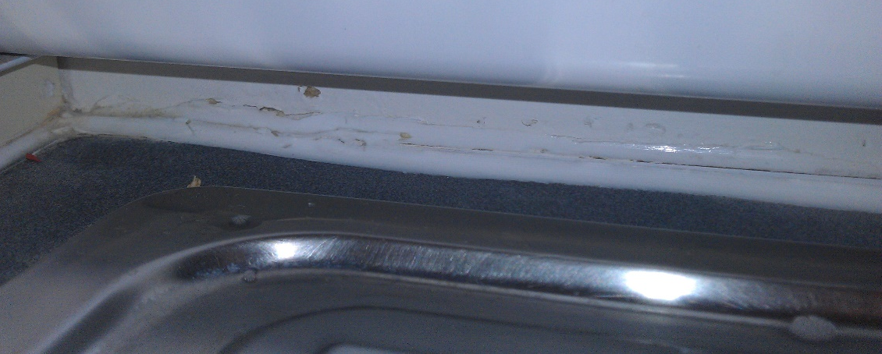
Setting (1)

Typing by PFGE showed the patient isolates to be identical, outbreak meetings were held regularly and the following interventions were undertaken:
  - Increased ward and cubicle cleaning
  - Reduced visitors
  - Reduced movement of equipment
  - Reduced antibiotic prophylaxes

Due to the possible environmental nature of the outbreak you decide to undertake environmental screening for the organism.

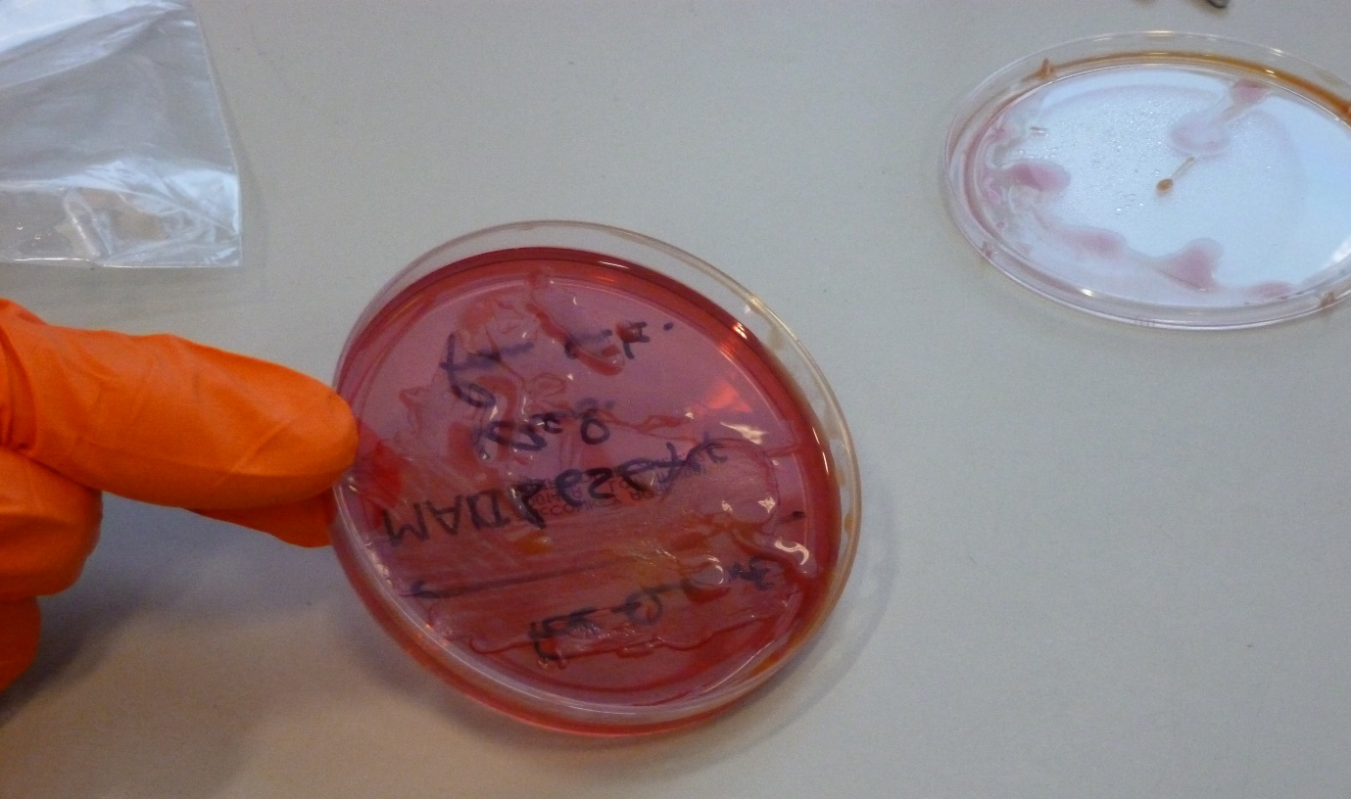

Questions:

- What aspects of Klebsiella pneumoniae mean that is might be environmentally transmitted?
- How does this knowledge help you decide where to screen?
- Do you have a Trust policy for where you might screen in bed spaces/shared ward areas?
- How would you screen:
  - Who would do the screening?
  - What methods would you use?
  - How many samples would you take?
  - Which areas of the ward space would you screen (shared ward, bedspaces (all), bed spaces (affected)
  - Who would process the samples?

Setting (2)

21 swabs taken of shared ward areas, including:
  - Floors
  - Door handles
  - Nurses station
  - Keyboards
  - Cupboard and trolleys
  - Telephone
  - ISTAT
  - Sinks
- 1 positive swab for the same strain detected, taken from the IV room sink

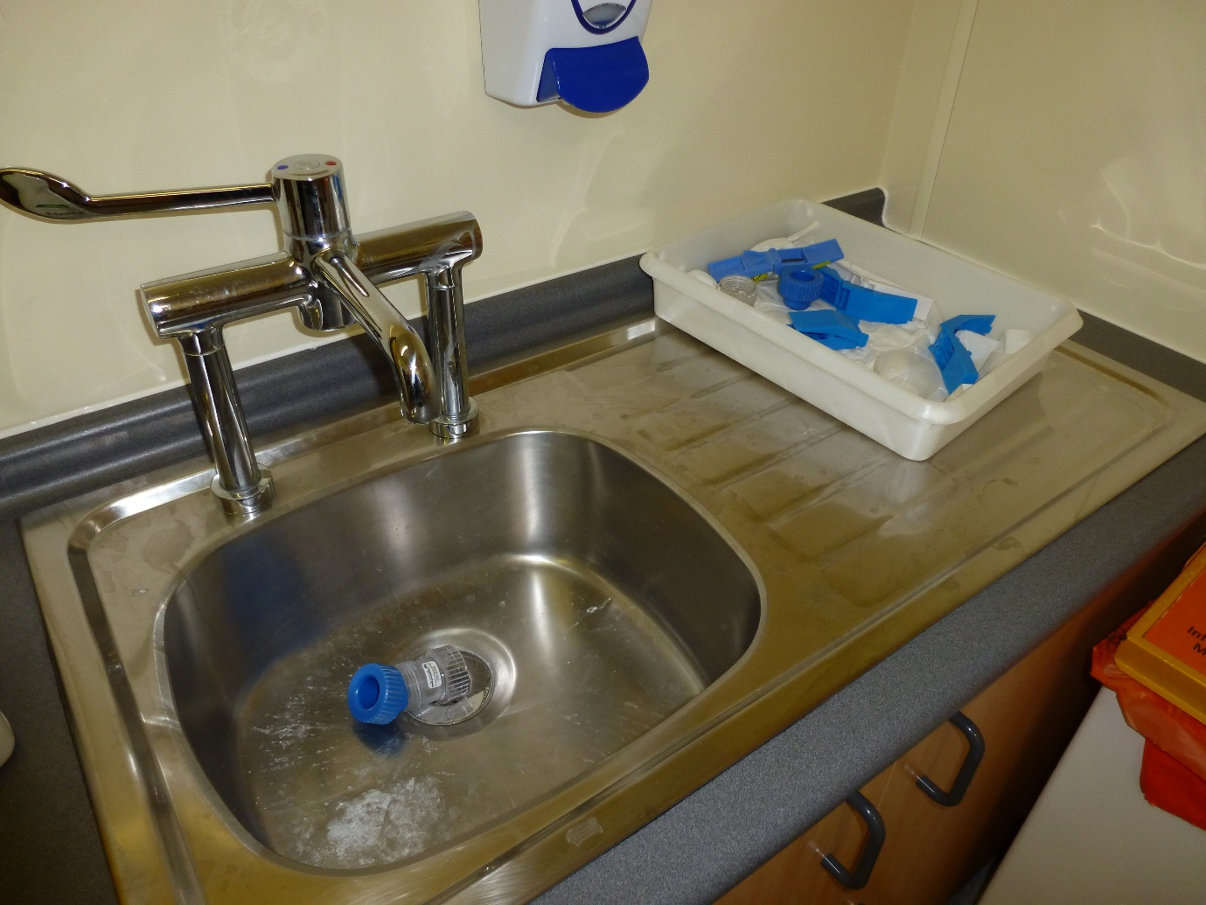

Samples were processed using antibiotic broth enrichment for 24 hours (Meropenem + Vancomycin broth) and then sub-cultured onto non-selective agar

3 more patients were detected with the same strain including a previous patient who was detected positive on their admission stool

Questions:

- Would you undertake any further environmental screening at this point?
- What actions might you take linked to the positive sink?
- Do you have any comments on the design of the sink?
Setting (3)

Infection control interventions still in place, including 2 hourly cleaning and changes in sink use. Environmental screening was repeated including both cubicles and shared ward areas to identify reservoir (100 swabs taken in 5 cubicles occupied by positive patients and a further 30 of shared ward areas)

No positive environmental sites detected in patient cubicles, despite 1 long term patient being in the same cubicle for over 3 months. Positive samples include:
  - IV room sink bowl and lips (same site that was positive in November)
  - Medication room sink
  - Entrance way sink plug hole

Sinks being cleaned 2 hourly with chlorine begin to look like the picture below:

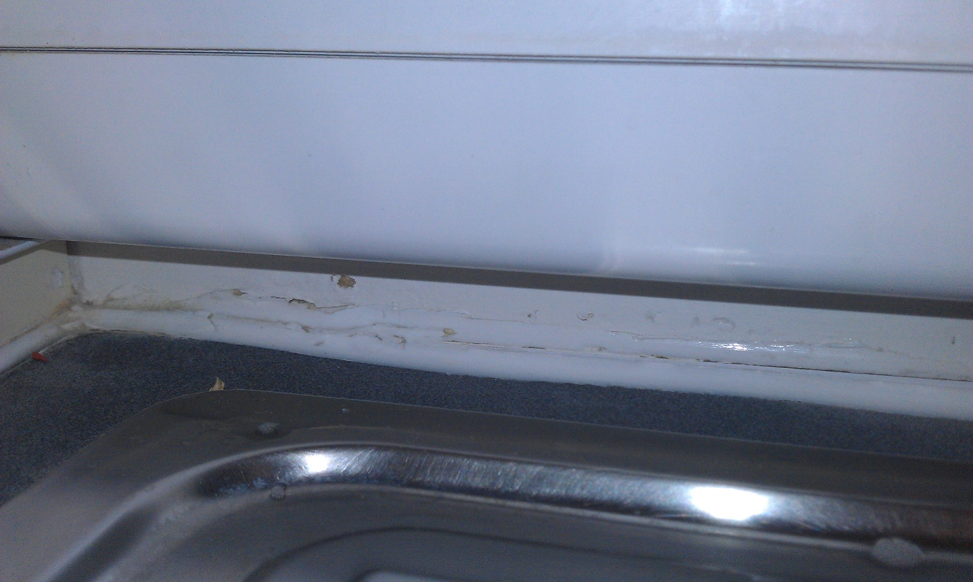

Questions:

Why do you think that the source detection was limited to the three sinks listed?
What do you think may have happened to the sink in the image and what affects might this have on environmental load?
What action would you take to now control the outbreak?

Setting (4)

Replacement sinks were specially commissioned to replace the contaminated units, at a cost of ~£160,000.00.

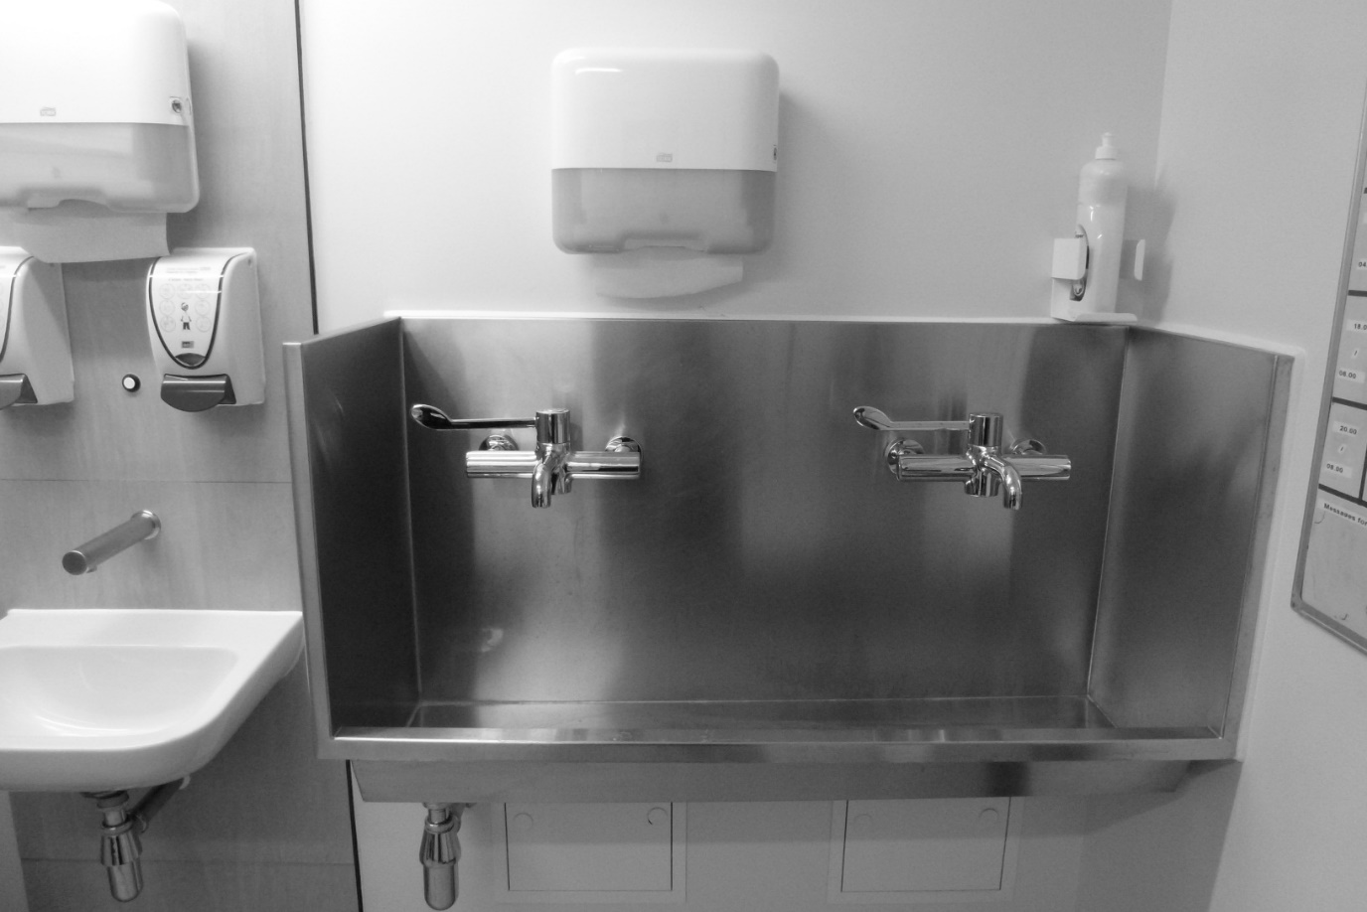

Questions:

What are the features of the sink pictured that may aid in preventing a repeat of this type of outbreak?
What involvement do you have at your Trusts in the selection of sink placement and design?

